**Contents**

Introduction……………………………………………………………………….

Team Members………………………………………………………………….

Roles………………………………………………………………………………….

Gantt Chart…………………………………………………………………………

Main Work Screenshots…………………………………………………….

Conclusion………………………………………………………………………….

## 

## **INTRODUCTION**

With the help of agile mythology, we create an android application on Sports App. In this app, there are two user one is admin and another is registered user. Admin is capable to maintain the all-CRUD operation related to App information regarding matches. Register user must create an account for run the application after login the user can easily access or search the match details by country and date.

# **TEAM MEMBERS**

**1.Rajbir**

**2.Gurpartap**

**3.Prabhjot**

## **ROLES**

**Rajbir**: Product Owner

**Gurpartap** : Scrum Master and Stakeholder

**Prabhjot**: Developer

## **GANTT CHART**

## **Main Work** **SCREENSHOT**

Country Table Screen Shot

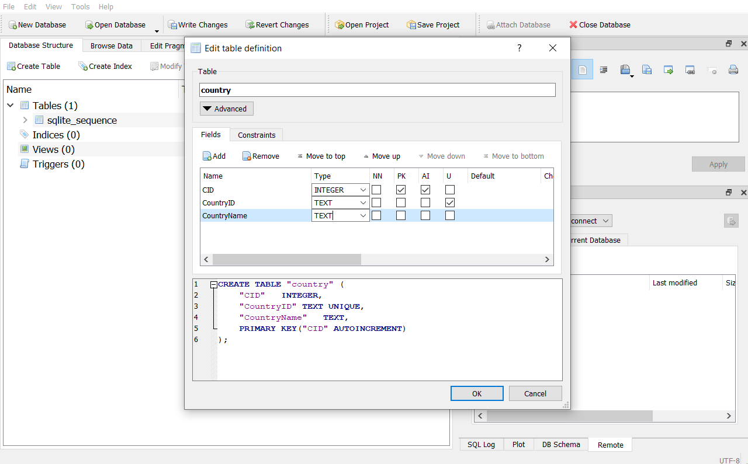

Profile Table Screen Shot

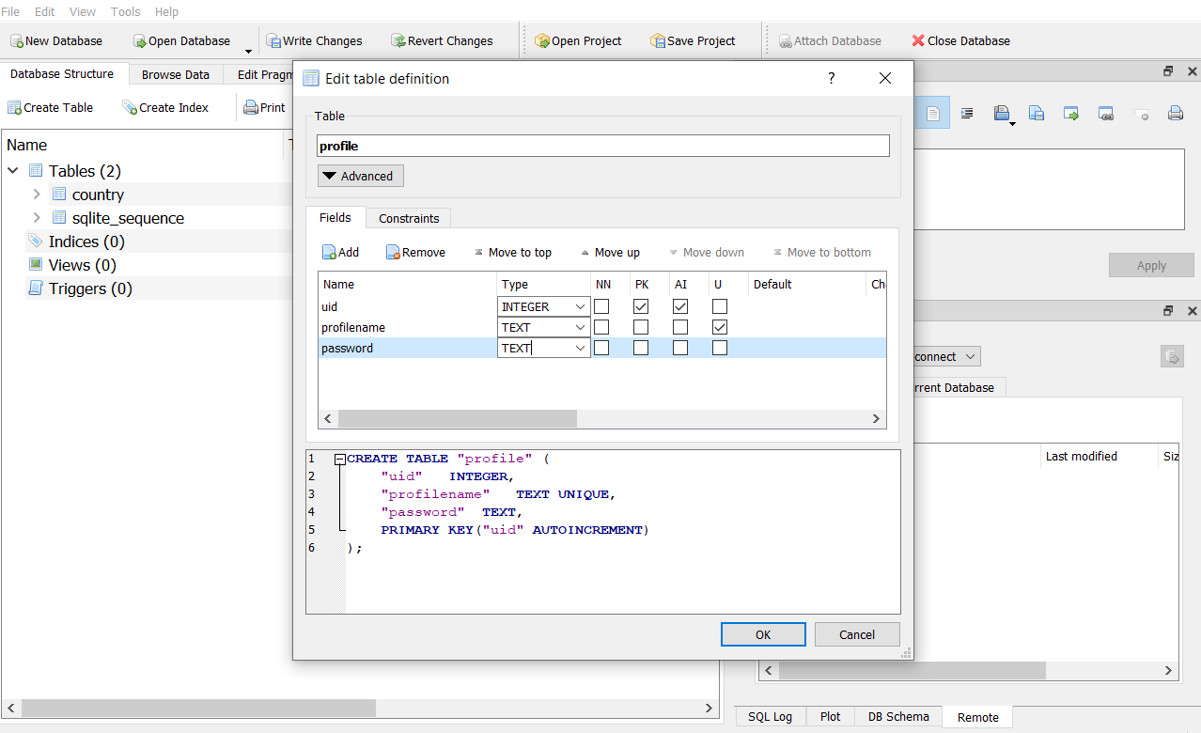

Match Table Screen Shot

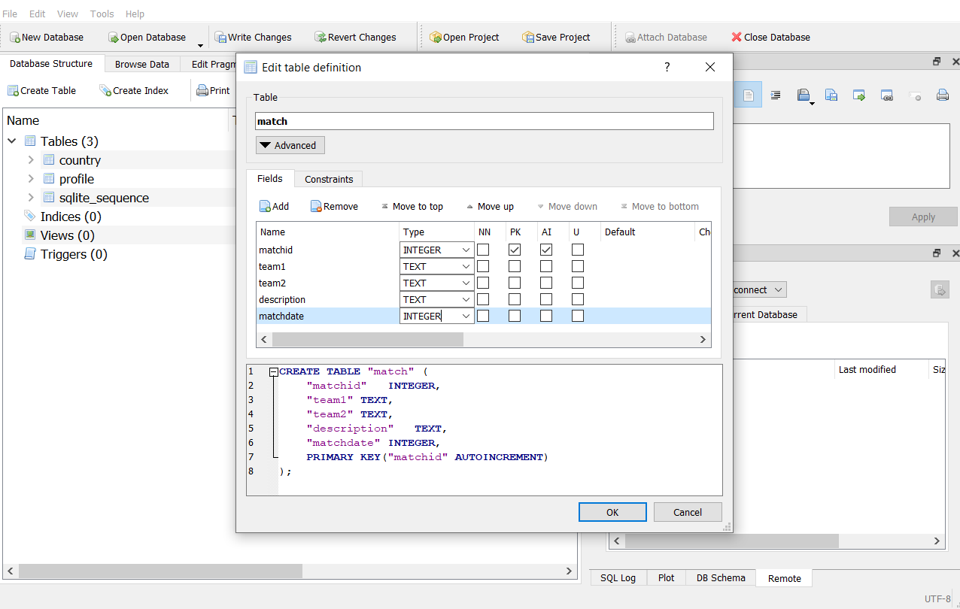

Splash Screen:



Admin Home Screen:

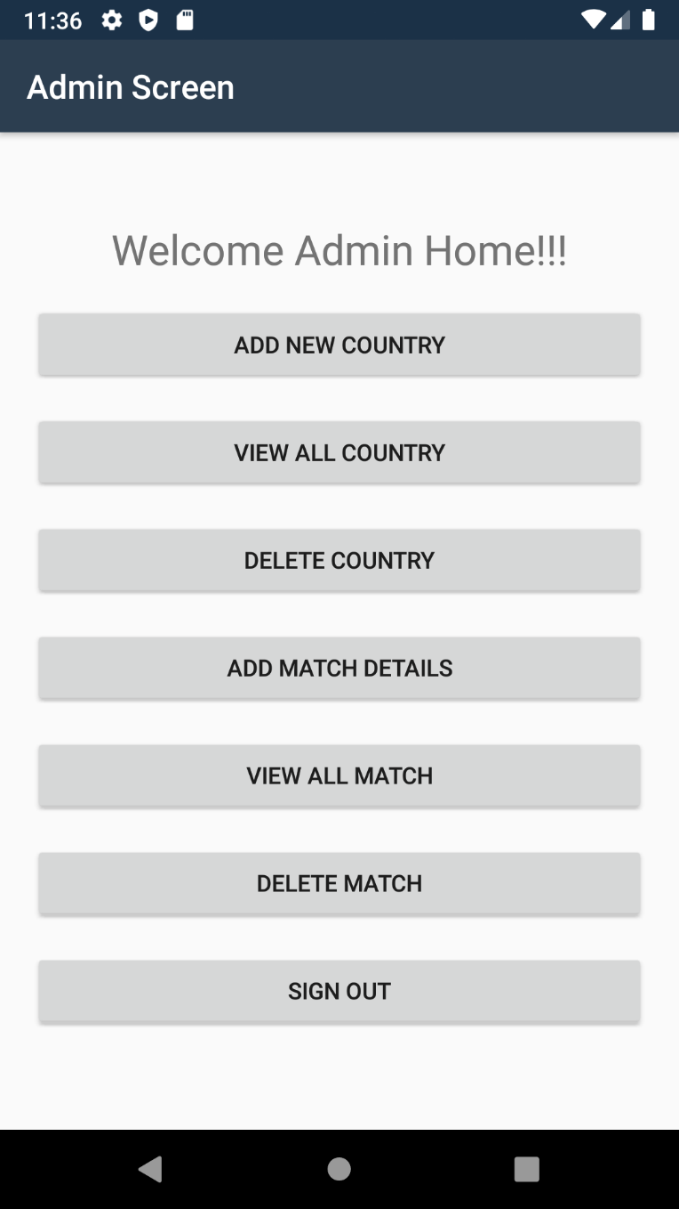

Add Country Screen:

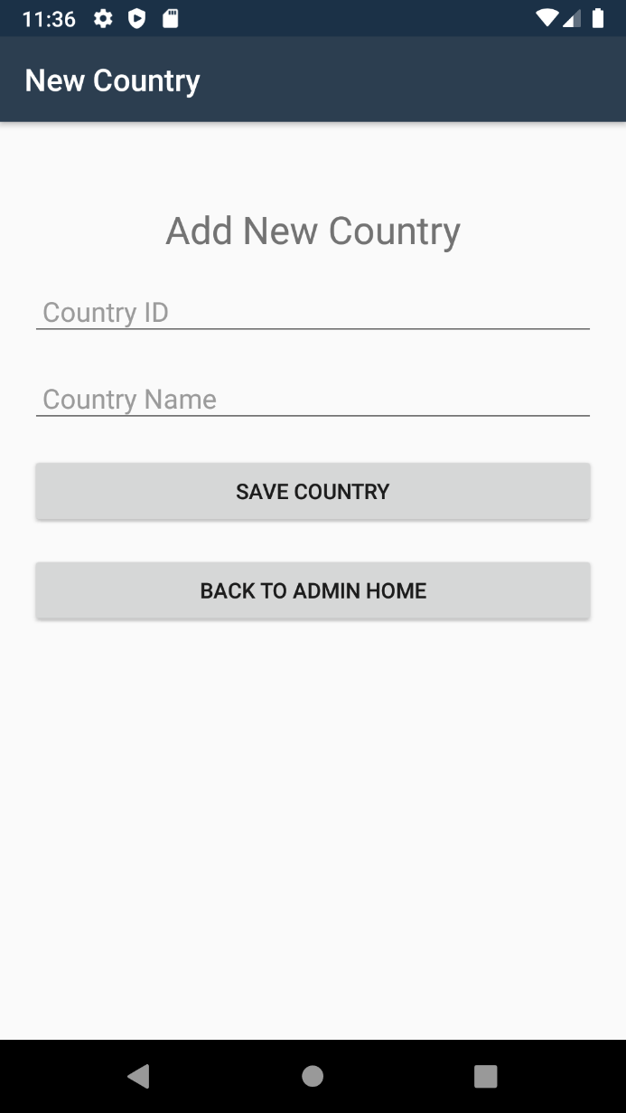

Delete Country Screen:

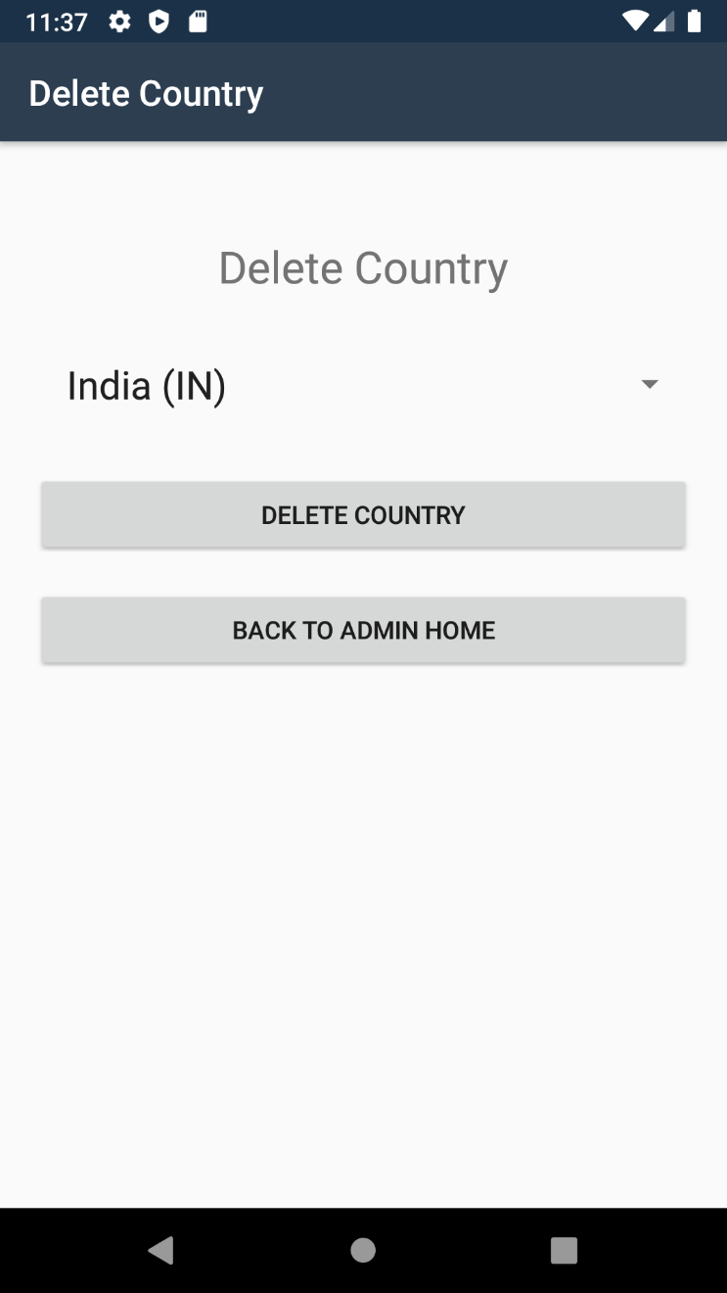

View All Country:

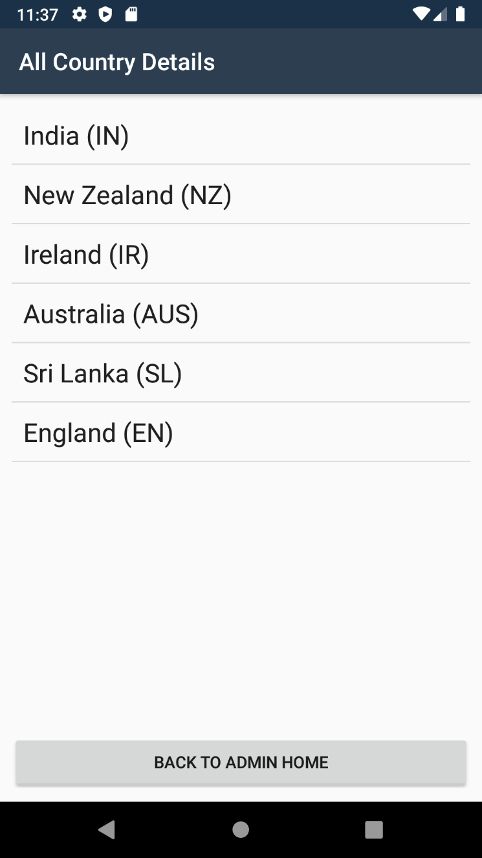

Add Match Screen:

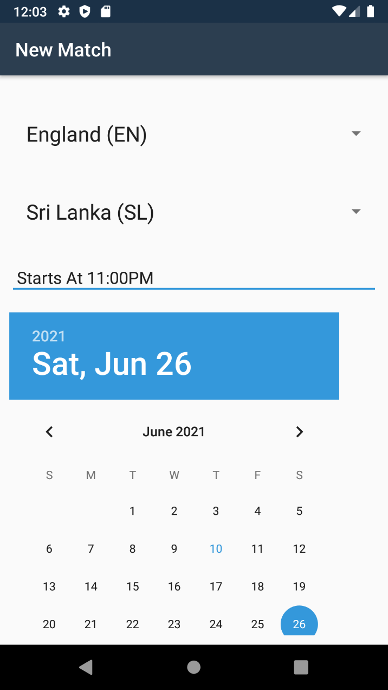

## **Conclusion**

Agile and scrum methodology are used by the project managers for keeping the track of work. As it quickly reacts to changes and is more flexible as compared to others.

To sum up, this application is for the user to register their details and search the match details according to country and date. If this application get chance to interact in market this will be suitable for the target audience and fulfil its main purpose.